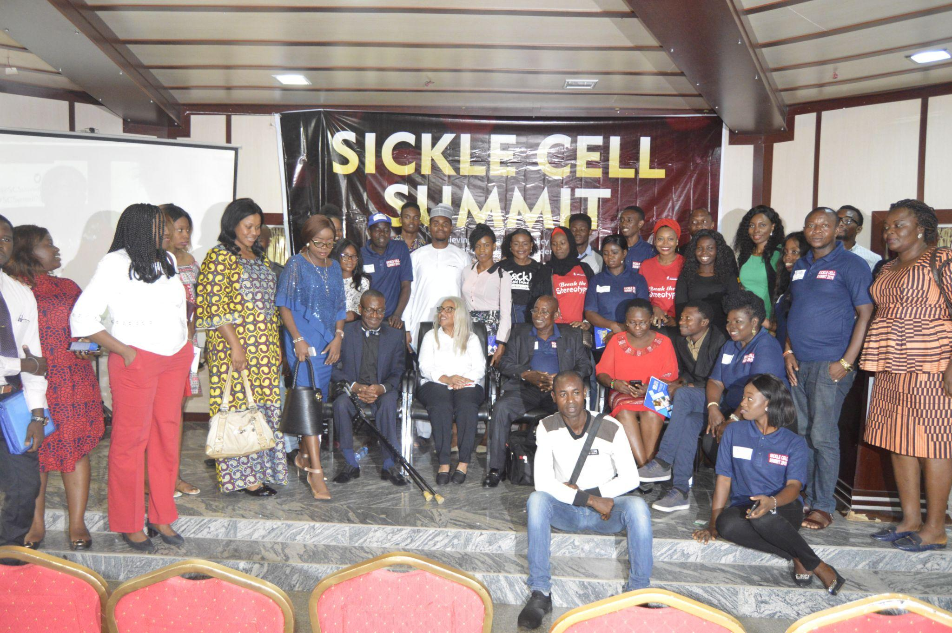

Sickle Cell Summit 3.0
Theme: Changing perceptions

About Sickle Cell Summit
Sickle Cell Summit 3.0 is a biennial advocacy event aimed at bringing stakeholders together to discuss issues affecting people living with Sickle Cell Disorder with a view to proffering sustainable solutions and policies that would greatly improve the health and wellbeing of People living with the condition.
This is the 3rd Series of the Sickle Cell Summit. The maiden edition was organised in 2019 at Chida Hotel, Abuja where over 200 participants were in attendance. These participants included Representatives of the Vice President, Law Makers, Sickle Cell Advocacy Organizations, Medical Practitioners, Regulatory Agencies , Representatives of the United States Mission in Nigeria and members of the Press.
Goal.
- To advocate for inclusive policies that will improve the health and wellbeing of people living with Sickle Cell Disorder.
- To create a forum where patients can advocate for inclusive health and wellbeing policies before policy makers.
- To equip health care workers with skills necessary to provide compassionate care to people with Sickle Cell Disorder,
- To provide up-to-date information on the latest advancement /therapies in sickle cell care.
- To create sustainable partnerships for sickle cell organizations to collaborate with a view to improve the health and well being of people with Sickle Cell Disorder.
- To create an avenue for patients and caregivers to share their experiences with a view to improve sickle cell care in Nigeria.
Who should attend this event? :
- Sickle Cell Warriors
- Sickle Cell Advocates
- Caregivers
- Health Care workers
- LawMakers in the National Assembly
- LawMakers in the State Houses of Assembly
- Law Students
- Legal Practitioners
- Medical Students
- Health and Wellness Companies
- Orthopaedic products companies
- Biomedical Companies
- Sickle Cell Organizations
- International Organizations/Agencies
- Regulatory Agencies
- Pharmaceutical Companies
- Sickle Cell Research Organizations
- Media Organizations

Sickle cell summit objectives
The objective of the Sickle Cell Summit is to create a forum where stakeholders in the Sickle care and advocacy can interact and brainstorm on issues affecting people with Sickle Cell Disorder in Nigeria with a view to creating innovative policies and solutions that will improve the health and wellbeing of people with Sickle Cell Disorder.

Reasons to attend

You will have the opportunity to make your voice heard in Sickle Cell policy Advocacy issues.
- You will learn from local and international experts about innovative trends and therapies in Sickle Cell Care and management .
- You will have the opportunity to network with stakeholders in Sickle cell care and advocacy.
- You will have the opportunity to showcase your products and services to a large audience made up of sickle cell warriors, caregivers, Sickle Cell Management organizations and stakeholders in the management of Sickle Cell Disorder.

Proposed Subthemes
- Media as an effective tool for sickle cell advocacy
- Expressing sickle cell advocacy through arts
- Catching up with sickle cell innovations & therapies in Africa: Barriers & Opportunities.
- The Empowered Warrior: Creating inclusive opportunities for growth.
- Building a culture of kindness and compassion in Sickle cell care.
- Reducing the burden of Sickle Cell Disorder through effective genotype testing

Timelines
- January- March,2023-Event planning and Call for speakers and sponsors suggestions.
- April-June,2023-Online program launch
- July 2023- 1st Major Announcement of Partners, Sponsors and Keynote Speakers
- July-August, 2023-Call for Exhibitors
- August 31,2023-Call for Exhibitors Deadline
- 14th September,2023-Sickle Cell Summit

Become a Sickle cell Summit Sponsor
The Sickle Cell Summit will provide an outstanding opportunity to promote your organization, to support your brand and to maintain a high profile among the world’s leaders in Sickle Cell care, advocacy, treatment and research.

The Sickle Cell offers your organization a unique platform for you to interact with an audience of over 200 delegates.
This means that you and your organization will highly contribute to and influence the further development of the Sickle Cell Management and research in sub-saharan Africa.
All partners and exhibitors will be acknowledged through various mediums throughout the summit.
An early confirmation will ensure an even higher level of exposure at the Sickle Cell Summit and we look forward to working with you to develop a package that can best suit your organization’s needs.

Sponsorship Categories
Platinum Sponsor-N1000,000 $1,330
- Company Name, logo and sponsorship level included in the Platinum sponsor category
- Speaking opportunities with the Sickle Cell Summit team at Press Conference and Media Advertisement
- Mention of sponsors in all radio hype/media commercials
- Sponsorship announcements on the Sickle Cell Summit Website, social media platforms and digital marketing campaigns.
- Opportunity to advertise your products and services on the Inside front Cover of the Sickle Cell Summit brochure.
- Opportunity to highlight/showcase a product or service offering
- Opportunity to speak at the Sickle Cell Summit
- Opportunity to host a breakout session
- Exclusive Summit Branding

Gold Sponsor-N500,000 $664
- Company Name, logo and sponsorship level included in the Gold sponsor category
- Mention of sponsors in all radio hype/media commercials
- Sponsorship announcements on the Sickle Cell Summit Website, social media platforms and digital marketing campaigns.
- Opportunity to advertise your products and services on the Middle Page of the Sickle Cell Summit brochure.(Full page)
- Opportunity to highlight/showcase a product or service offering
- Opportunity to host a breakout session
- Exclusive Summit Branding

Silver Sponsor-N250,000 $332
- Company Name, logo and sponsorship level included in the Silver sponsorship category
- Mention of sponsors in all radio hype/media commercials
- Sponsorship announcements on the Sickle Cell Summit Website, social media platforms and digital marketing campaigns.
- Opportunity to advertise your products and services in the Sickle Cell Summit brochure. (Half Page)
- Opportunity to host a breakout session
- Exclusive Summit Branding

Bronze Sponsor-N100,000 $132
- Company Name, logo and sponsorship level included in the Bronze sponsorship category
- Mention of sponsors in all radio hype/media commercials
- Sponsorship announcements on the Sickle Cell Summit Website, social media platforms and digital marketing campaigns.
- Opportunity to advertise your products and services in the Quarter page of the Sickle Cell Summit brochure.
- Exclusive Summit Branding

Exhibitors Category-N50,000 $66
The Sickle Cell Summit is also a wonderful opportunity for Exhibitors to showcase their products and services to a large audience and potential customers.

You can confirm your sponsorship through these four steps:
- Choose your preferred sponsorship based on your goals and interest
- Communicate your sponsorship choice to the Sickle Cell Summit team to confirm availability.
- Make payment to confirm and lock down sponsorship. You can make payments to
Account Name: TonyMay Foundation
Account Number:5210007974
Bank: Fidelity Bank Plc
- Send your proof of payments to tonymayfoundation@gmail.com to confirm receipt of payments.

Feedback from the past Sickle Cell Summit

Virginia Kirkwood-
Board Member,Uriel Owens Sickle Cell Disease Association of the Midwest
“Many thanks to the Tony May Foundation for helping to spread Sickle Cell awareness around the world. The discussion was most informative”

Bola Olufemi
Edo State Sickle Cell Centre

“Many thanks to the Tony May Foundation for helping to spread Sickle Cell awareness around the world. The discussion was most informative.”

Toyese Dehinbo

“Thank you very much for raising the bar in organizing the Sickle Cell summit. I was in attendance and was delighted about the energy and wealth of knowledge in the room. It felt like a “situation room”. Very well done!.”

Follow us :@tonymayfoundation_tmf -Instagram
@tonymayf - Twitter
@tonymayfoundation- Facebook |Linkedin

